Visual Builder utilization example

First opening of the plugin

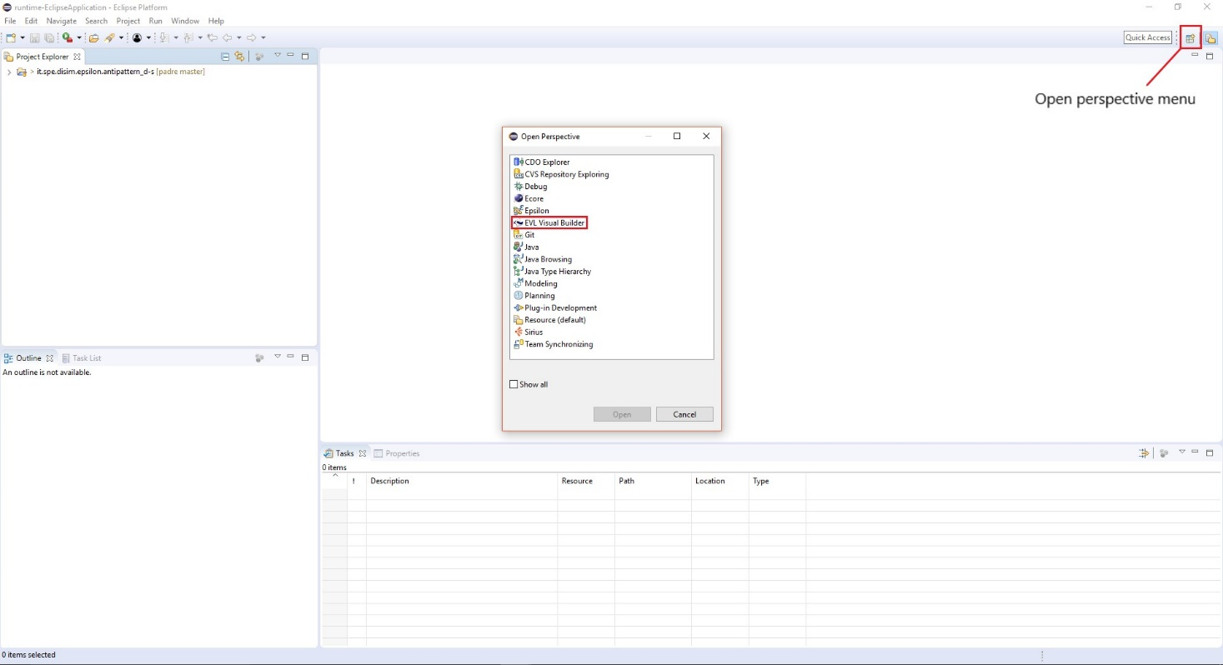

Main interface (start downloading code from database)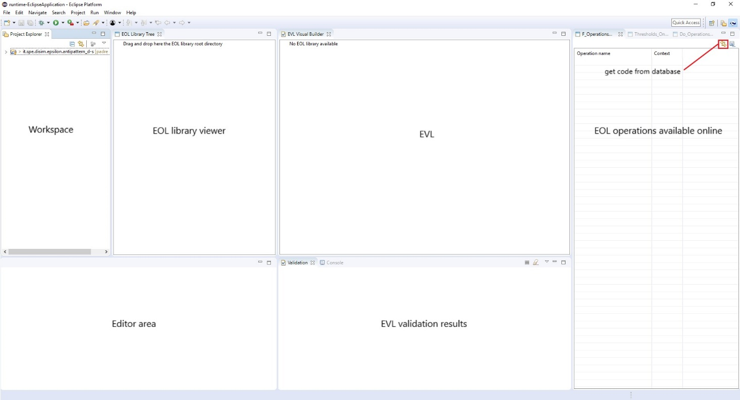

Start creating a library of EOL operations copying them from online database: first create a directory representing the library in the workspace (EOL_library in the example), then click the ‘Save’ button for each of the list on the right (F_Operations, Thresholds, Do_Operations) and save the .eol files in the directory already created.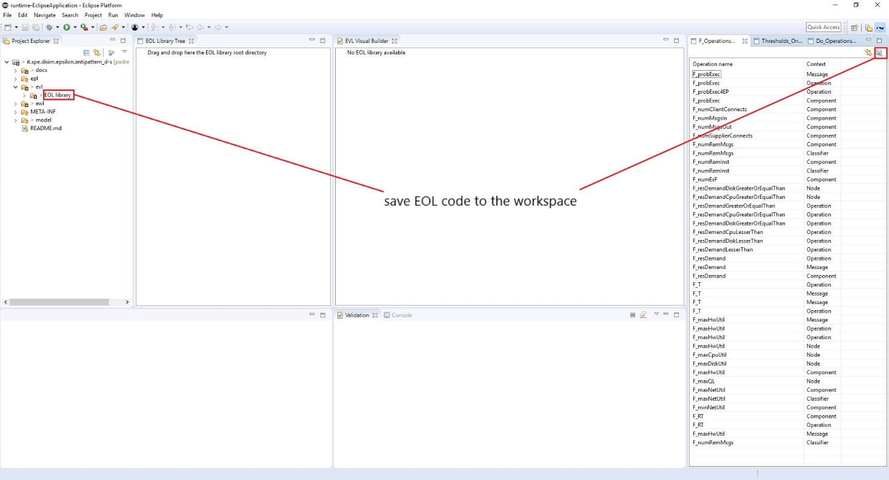

Populate the library viewer making a drag and drop of the library root directory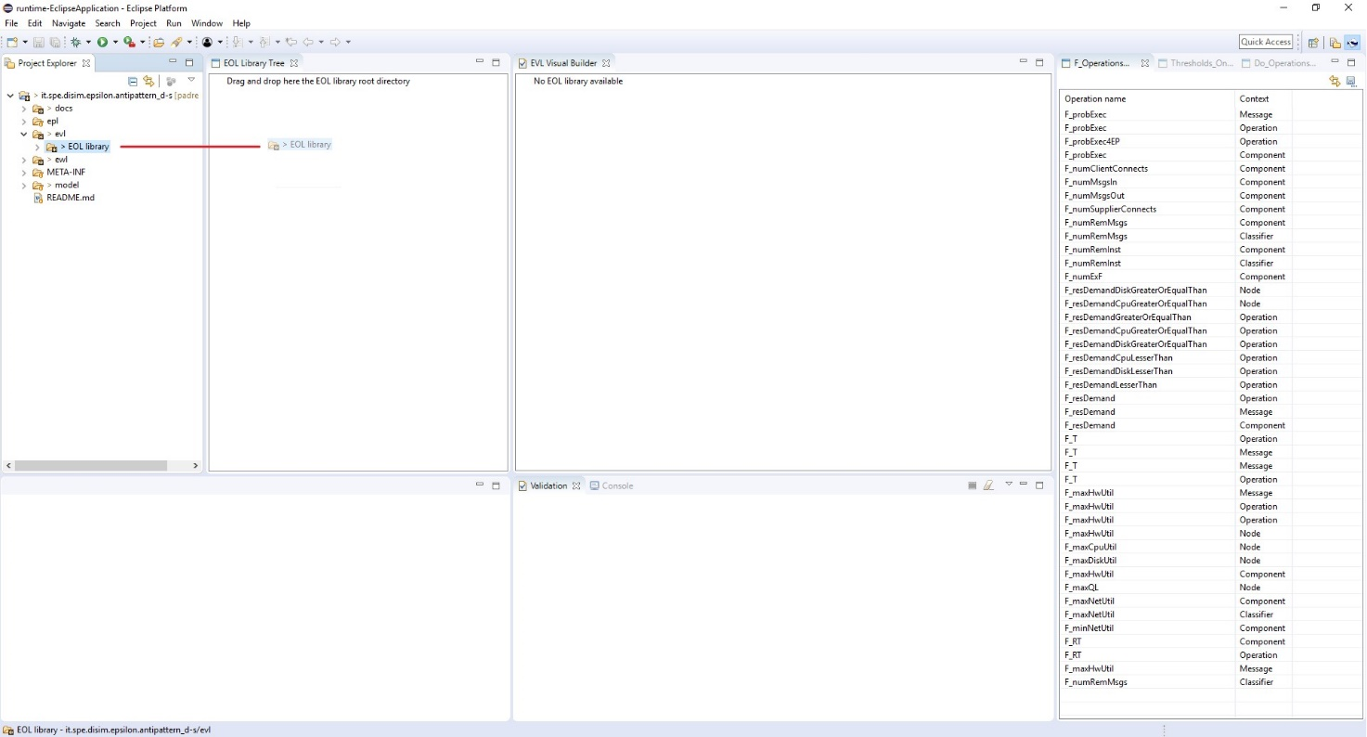

Creating the EVL tree (1)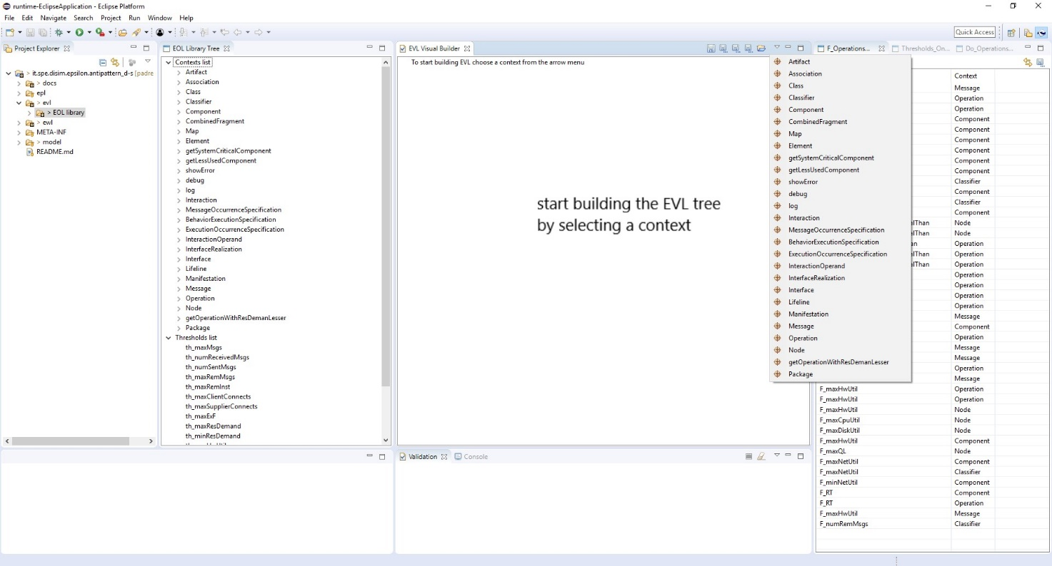

Creating the EVL tree (2)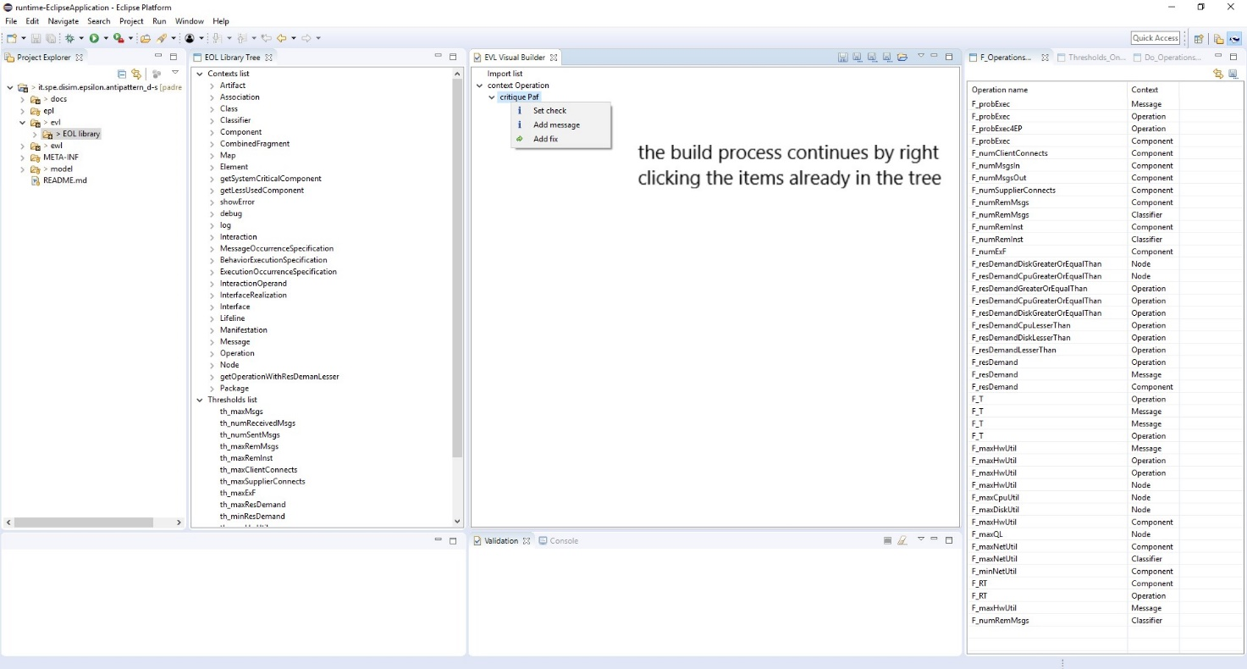

Creating the EVL tree (3)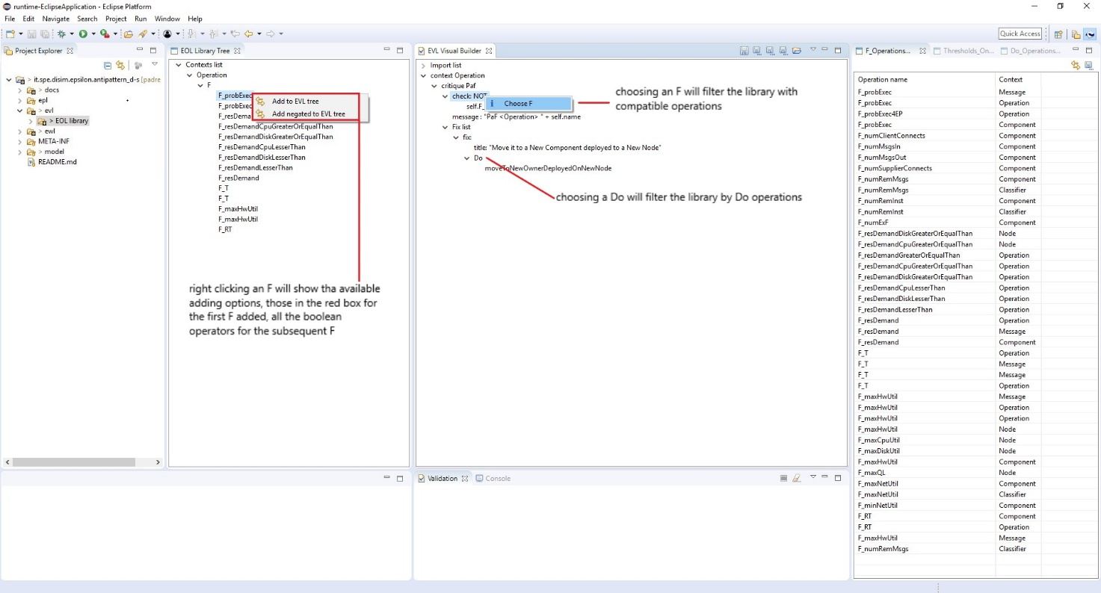

Creating the EVL tree (4)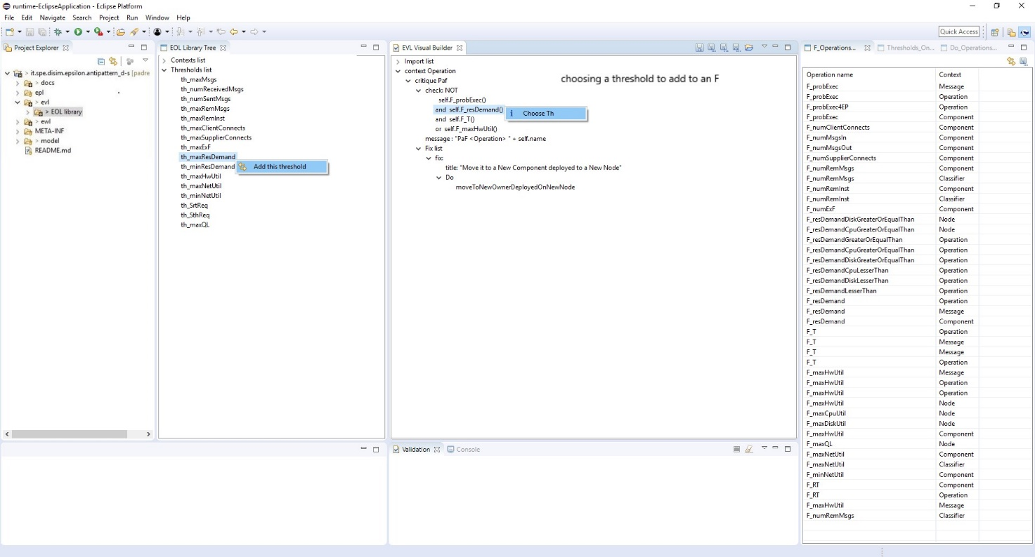

Saving the EVL tree to EVL, EPL, and EWL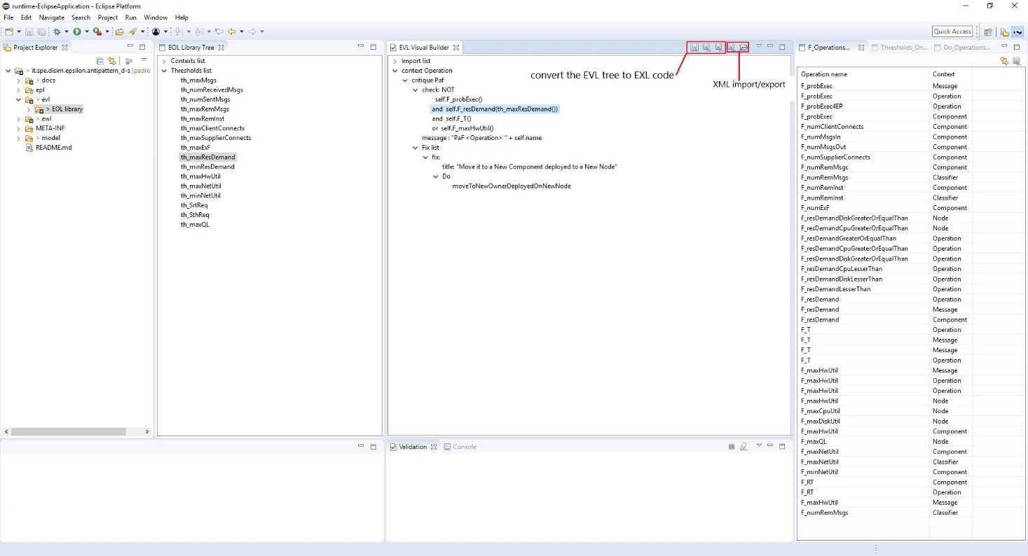

Result (for the validation please follow Epsilon guide)